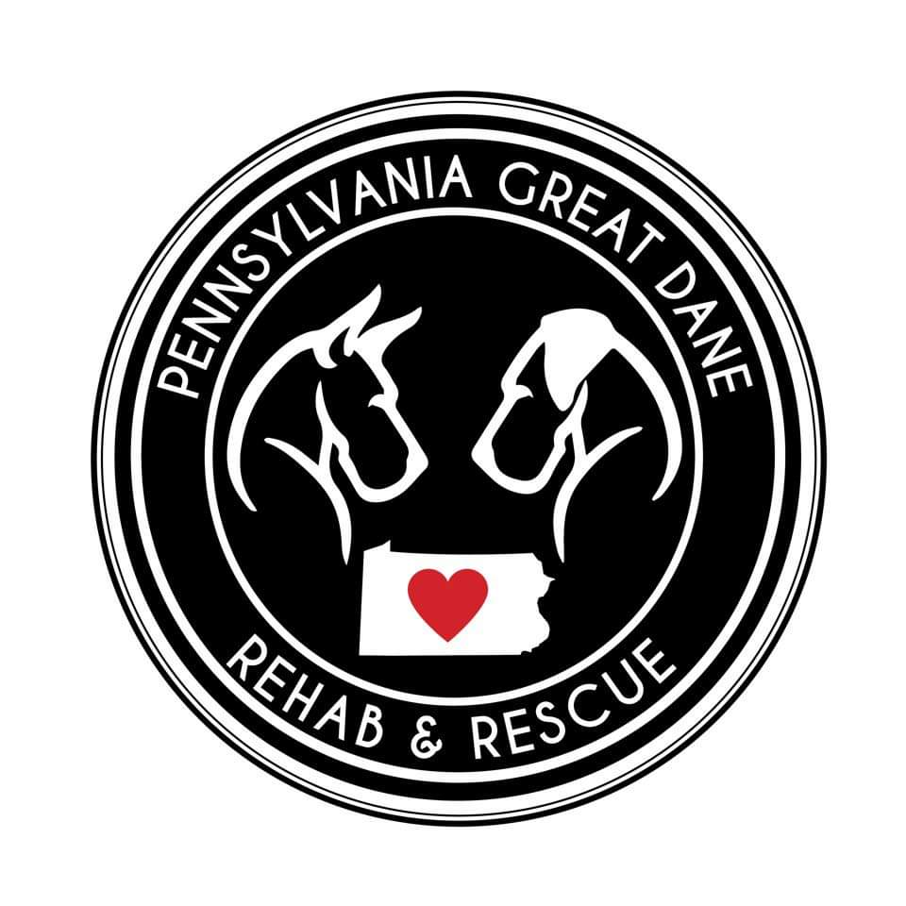
Parescuedanes@gmail.com

2450 Eastbrook Road
New Castle, PA 16105

ADOPTION APPLICATION
Instructions: Please read this Application, fill in the blanks, sign it, and return it to us at the address above. The information you provide in this Application and during our interview will help us find a good match for you.
Name: ____________________________________________________________________________
Address: ___________________________________________________________________________
___________________________________________________________________________
City: _________________________________________ State: ____________ Zip: ____________
Home Phone Number: _______________________________________________________________
Cell Phone Number: __________________________________________________________________
Email Address: ____________________________________________________________________

Please provide the following information about your home, your children (if any), and your pets (if any):

YOUR HOME:
Do you own or rent your home? _____________________________________________
Landlord Name (if applicable): _______________________________________________
Landlord Phone Number (if applicable): _______________________________________
How long have you lived here (years or months)? ________________________________
Dwelling Type:
___ ​ Single Family, ___ Duplex, ___Townhouse,
___ Apartment, ___Mobile Home , ___ Other (Please specify) ______________________

Initial Below Fields to Confirm Acceptance/Understanding:
Do you have a fenced yard? Yes ___________No _____________
If “Yes,” how high is your fence?_____________________
If “No,” you have to be willing and able to take the dog outside ON A LEASH for relief and exercise at least three or four times every day. __________ (Please initial)
You are aware that your Great Dane MUST be kept on a leash AT ALL TIMES when not in a fenced in area. __________ (Please initial)

You must keep a collar BEARING IDENTIFICATION, CURRENT LICENSE AND VACCINATION TAGS, on your Great Dane at all times, and further, notify Pennsylvania Dane Rescue, Inc. __________(Please initial)

Great Danes MUST LIVE WITHIN THE HOME. They CANNOT LIVE outdoors in a kennel or dog house, be chained up, put on a wire run or be kept outside in any fashion on a permanent basis. You agree to keep your new pet inside your house __________ (Please initial)

Is there a family member home during the day? ​___ Yes ​___ No
If “No,” how many hours a day will the Great Dane be left alone? ______________

Where will you keep your dog when you’re not home? (Check everything which applies):
□​Crated □​ Locked in room □​ Basement □​ Bathroom
□​ Porch □​ Garage □​ Other (please specify): ________________________________________

Where will he/she sleep at night? (Check everything which applies):
□Crated □Locked in room □Basement □Bathroom
□Kitchen □​Bedroom □ Other (please specify): _______________________________________

YOUR FAMILY:
Number of adults, including yourself? _________________________________________________
Do you have any children, including any who visit on a regular/frequent basis? _____Yes ​ _____No​ ​
If “Yes,” please list how many, their age and gender
Number of Children:__________________________
Age:______________ Gender: __________________
Age:______________ Gender: __________________
Age:______________ Gender: __________________
Age:______________ Gender: __________________
Age:______________ Gender: __________________
Age:______________ Gender: __________________

Does anyone in the household have animal allergies? ​_____Yes ​ _____No​
Are other members of your household enthusiastic about adopting a Dane? _____Yes ​ _____No​
Who will be primarily responsible for the care of this dog? _______________________________
Do you currently have other pets? If yes, please list ___________________________________ ______________________________________________________________________________

What pets have you had in the past? _________________________________________________

Veterinarian’s Name: ______________________________________________________________
Veterinarian’s Phone Number: _______________________________________________________
Are you familiar with the health problems associated with this breed (i.e. Short Life Span/Bloat/Gastric Torsion, Hip/Elbow Dysplasia)? _____Yes ​ _____No​
Are you aware of, and prepared for, the financial responsibility of having a “GIANT” breed (i.e. Food
Cost, Licensing, Routine Veterinary Care)? ​ ​_____Yes ​ _____No​

Why do you want a Great Dane? _______________________________________________________
__________________________________________________________________________________
__________________________________________________________________________________
Why did you decide to adopt rather than purchase a puppy? ________________________________
__________________________________________________________________________________
__________________________________________________________________________________

Initial Below Fields to Confirm Acceptance/Understanding:
Dogs adopted through Pennsylvania Great Dane Rescue come to their new owners already spayed/neutered, with inoculations current within six months, initial worming, flea treatment and a heart worm check. In exchange for these medical services and to help defray our group’s expenses, there is an ADOPTION DONATION, which IS NON-REFUNDABLE. _______________ (Please initial)
A premise inspection/home evaluation, conducted by Pennsylvania Great Dane Rescue representative(s) is required. _______________ (Please initial)
When would the most convenient day and time be for you?_________________________________

__________________________________________________________________________________

You understand that your ownership of this Great Dane will be subject to the conditions set forth in this application, and that if the dog is judged to be kept in an unacceptable fashion by Pennsylvania Great Dane Rescue, or any portion of this application has been falsified, Pennsylvania Great Dane Rescue is entitled to regain ownership of the dog. _______________ (Please initial)

You take full responsibility for any future liability concerning this dog, once you have taken custody. This includes any type of vet care as well as any dog bites or injury that has occurred from the dog adopted by the new adopting party and cannot hold Pennsylvania Great Dane Rescue, Inc. responsible in any way. _______________ (Please initial)
Should you be unable to care for any dog you adopt from the Pennsylvania Great Dane Rescue, Inc. for any reason, you agree that you will return the dog to the Pennsylvania Great Dane Rescue, Inc.
_______________ (Please initial)
**Refusal of 6 month home check and evaluation will result in automatic denial of application and if a dog has been adopted to you and your refuse the 6 month after adoption home check a local dog law enforcement officer and a PGDR representative will come your home anyhow to ensure that the dog is safe and in humane conditions, which can result in confiscation of the dog, non-refunded adoption fee and denial of further adoptions with PGDR. _______________ (Please initial)

The Applicant(s), including all adults in the household, agree that this is a CONTRACT entered into with Pennsylvania Great Dane Rescue, Inc. and, as such, is binding. I/We hereby certify that all the information contained on this ADOPTION APPLICATION is true and correct to the best of my/our knowledge and I/we agree to the terms specified herein:
Applicant 1:
Print Name: _______________________________________________________________________
Signature: _________________________________________________________________________
Date ____/____/________
Applicant 2 (if applicable):
Print Name: _______________________________________________________________________
Signature: _________________________________________________________________________
Date ____/____/________

