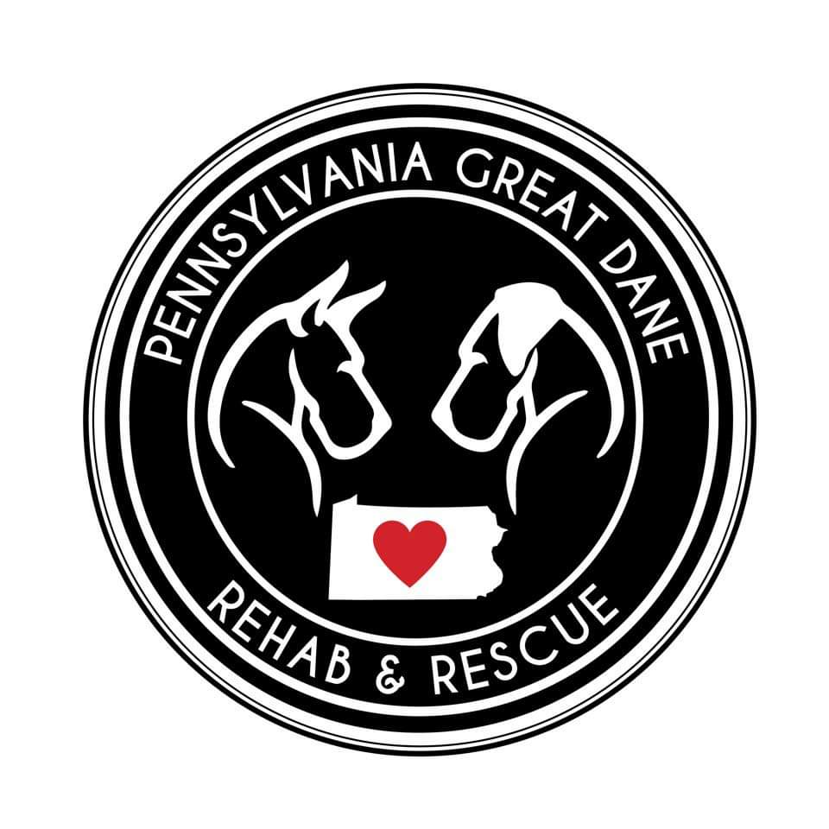

Parescuedanes@gmail.com

2450 Eastbrook Road

New Castle, PA 16105

**ADOPTION APPLICATION**

**Instructions:** Please read this Application, fill in the blanks, sign it, and return it to us at the address above. The information you provide in this Application and during our interview will help us find a good match for you.

Name: ____________________________________________________________________________

Address: ___________________________________________________________________________

___________________________________________________________________________

City: _________________________________________ State: ____________ Zip: ____________

Home Phone Number: _______________________________________________________________

Cell Phone Number: __________________________________________________________________

Email Address: ____________________________________________________________________

Are you applying at other rescues?_____________________________________________________

If we have a dog that fits your home we can process and place within a week, if you have applied other places, please let us know.

Occupation_____________________________________________________________

Are you currently employed?___________________________________________________

How soon are you looking to adopt a dog___________________________________________________

Please provide the following information about your home, your children (if any), and your pets (if any): **YOUR HOME:**

Do you own or rent your home? _____________________________________________

Landlord Name (if applicable): _______________________________________________

Landlord Phone Number (if applicable): _______________________________________

How long have you lived here (years or months)? ________________________________

Dwelling Type:

___ ​ Single Family, ___ Duplex, ___Townhouse,

___ Apartment, ___Mobile Home , ___ Other (Please specify) ______________________

**Initial Below Fields to Confirm Acceptance/Understanding:**

Do you have a fenced yard? Yes ___________No _____________

If “Yes,” how high is your fence?_____________________

If “No,” you have to be willing and able to take the dog outside ON A LEASH for relief and exercise at least three or four times every day. __________ **(Please initial)**

You are aware that your Great Dane MUST be kept on a leash AT ALL TIMES when not in a fenced in area. __________ **(Please initial)**

You must keep a collar BEARING IDENTIFICATION, CURRENT LICENSE AND VACCINATION TAGS, on your Great Dane at all times, and further, notify Pennsylvania Dane Rescue, Inc. __________**(Please initial)**

Great Danes MUST LIVE WITHIN THE HOME. They CANNOT LIVE outdoors in a kennel or dog house, be chained up, put on a wire run or be kept outside in any fashion on a permanent basis. You agree to keep your new pet inside your house __________ **(Please initial)**

Is there a family member home during the day? ​___ Yes ​___ No

If “No,” how many hours a day will the Great Dane be left alone? ______________

Where will you keep your dog when you’re not home? (Check everything which applies):

□​Crated □​ Locked in room □​ Basement □​ Bathroom

□​ Porch □​ Garage □​ Other (please specify): ________________________________________

Where will he/she sleep at night? (Check everything which applies):

□Crated □Locked in room □Basement □Bathroom

□Kitchen □​Bedroom □ Other (please specify): _______________________________________

**YOUR FAMILY:**

Number of adults, including yourself? _________________________________________________

Do you have any children, including any who visit on a regular/frequent basis? _____Yes ​ _____No​ ​

If “Yes,” please list how many, their age and gender

Number of Children:__________________________

Age:______________ Gender: __________________

Age:______________ Gender: __________________

Age:______________ Gender: __________________

Does anyone in the household have animal allergies? ​_____Yes ​ _____No​

Are other members of your household enthusiastic about adopting a Dane? _____Yes ​ _____No​

Who will be primarily responsible for the care of this dog? _______________________________

Do you currently have other pets? If yes, please list ______

Type___________________ Age______________ M/F___________ Altered?_________________

Type___________________ Age______________ M/F___________ Altered?_________________

Type___________________ Age______________ M/F___________ Altered?_________________

Type___________________ Age______________ M/F___________ Altered?_________________

What pets have you had in the past? If yes, please list____

Type___________________ Age______________ M/F___________ Altered?_________________

Type___________________ Age______________ M/F___________ Altered?_________________

Type___________________ Age______________ M/F___________ Altered?_________________

Type___________________ Age______________ M/F___________ Altered?_________________

Have you had to surrender, perform Humane Euthanasia, or Behavioral Euthanasia on a pet before?

If yes please explain________________________________________________________________________________________________________________________________________________________________________________________________________________________________________________________________________________________________________________________________________________________________________________________________________________________________________________________________________________________________________________________

***\*\*\*\*PLEASE CONTACT YOUR VET FOR APPROVAL FOR US TO SPEAK WITH THEM PRIOR TO APPLICATION RETURN. This helps quicken our approval process\*\*\*\*\*\****

Veterinarian’s Name: ______________________________________________________________

Veterinarian’s Phone Number: _______________________________________________________

Are you familiar with the health problems associated with this breed (i.e. Short Life Span/Bloat/Gastric Torsion, Hip/Elbow Dysplasia)? _____Yes ​ _____No​

Are you aware of, and prepared for, the financial responsibility of having a “GIANT” breed (i.e. Food

Cost, Licensing, Routine Veterinary Care)? ​ ​_____Yes ​ _____No​

Why do you want a Great Dane? _______________________________________________________

__________________________________________________________________________________

__________________________________________________________________________________

Why did you decide to adopt rather than purchase a puppy? ________________________________

__________________________________________________________________________________

__________________________________________________________________________________

***Initial Below Fields to Confirm Acceptance/Understanding:***

Dogs adopted through Pennsylvania Great Dane Rescue come to their new owners already spayed/neutered, with inoculations current within six months, initial worming, flea treatment and a heart worm check. In exchange for these medical services and to help defray our group’s expenses, there is an ADOPTION DONATION, which IS NON-REFUNDABLE. If a dog is not altered there will be a contract in place to alter within 3 months or a medical exemption. _______________ **(Please initial)**

***HOME INSPECTION***

A premise inspection/home evaluation, conducted by Pennsylvania Great Dane Rescue representative(s) is required. **_______________ (Please initial)**

When would the most convenient day and time be for you?_________________________________

__________________________________________________________________________________

***ADOPTION/OWNERSHIP***

You understand that your ownership of this Great Dane will be subject to the conditions set forth in this application, and that if the dog is judged to be kept in an unacceptable fashion by Pennsylvania Great Dane Rescue, or any portion of this application has been falsified, Pennsylvania Great Dane Rescue is entitled to **regain ownership of the dog.** **_______________ (Please initial)**

***RESPONSIBILITY***

**You take full responsibility for any future liability concerning this dog, once you have taken custody**. This includes any type of vet care as well as any dog bites or injury that has occurred from the dog adopted by the new adopting party and cannot hold Pennsylvania Great Dane Rescue, Inc. responsible in any way. **_______________ (Please initial)**

***RETURN OR SURRENDER BACK***

Should you be unable to care for any dog you adopt from the Pennsylvania Great Dane Rescue, Inc. for any reason, **you agree that you will return the dog to the Pennsylvania Great Dane Rescue**.

What you need to do to return the dog

-Surrender form completely filled out and any medical records

-If you are **out of state** per PA State Law we need- surrender form, HEALTH CERTIFICATE (conducted by a licensed vet stating that the dog is free of infectious disease and parasites), and all medical records.

Without these things we cannot take the dog back, also there is a huge shortage in kennel space and foster homes so a wait time is to be expected.

**_______________ (Please initial)**

***TRANSPARENCY***

*Everything we know about the dog you are adopting has been told to you. Any behaviors in the home are as new to us as they are to you. Because we get very little in details about the dog, we test for behaviors but kennel life is very different than home life so you may see things that the dog did not present while in our care. You know what we know. **___________________(Please initial)**

*Refusal of ANY home check and evaluation will result in automatic denial of application and if a dog has been adopted to you and your refuse the 6 month after adoption home check a local dog law enforcement officer and a PGDR representative will come your home anyhow to ensure that the dog is safe and in humane conditions, which can result in confiscation of the dog, non-refunded adoption fee and denial of further adoptions with PGDR. **_______________ (Please initial)**

The Applicant(s), including all adults in the household, agree that this is a CONTRACT entered into with Pennsylvania Great Dane Rescue, Inc. and, as such, is binding. I/We hereby certify that all the information contained on this ADOPTION APPLICATION is true and correct to the best of my/our knowledge and I/we agree to the terms specified herein:

**Applicant 1:**

Print Name: _______________________________________________________________________

Signature: _________________________________________________________________________

Date ____/____/________

**Applicant 2 (if applicable):**

Print Name: _______________________________________________________________________

Signature: _________________________________________________________________________

Date ____/____/________

Thank you for choosing adoption! To expedite the process please:

* Call and allow permission for us to speak with your Vet.
* Home photos
* Foster to Adopt paper

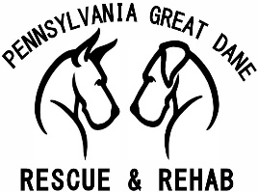Welcome to our foster to adopt program

With the new year we decided, with the lack of fosters and funds, to instill a new program to help us save more lives.

Program requirements

1. All dogs in house are to be spayed/neutered and up to date on vaccines.
2. Less than 5 dogs in home.
3. Complete transparency on behaviors, with personal dogs and potential foster to adopt dogs.
4. Some availability for transport and vet care.
5. If the dog you are fostering does not turn out to be the dog for you, we will need between 14-30 days to find new placement for dog. Unless in emergency cases.
6. You have 14-day trial period to decide to keep the dog and pay the adoption fee.
7. Have a completed application on file along with home check.

PRINTED NAME DATE

|  |  |
| --- | --- |
|  |  |
|  |  |

ADDRESS

|  |
| --- |
|  |



PLEASE NOTE THAT IN SIGNING THIS YOU HAVE ACKNOWLEGDED ALL THAT IS ABOVE, MEET REQUIREMENTS, AND AGREE.